**Project 2:How to create new instances using amazon machine images**

* **Created Instance as karthik-backup-server**

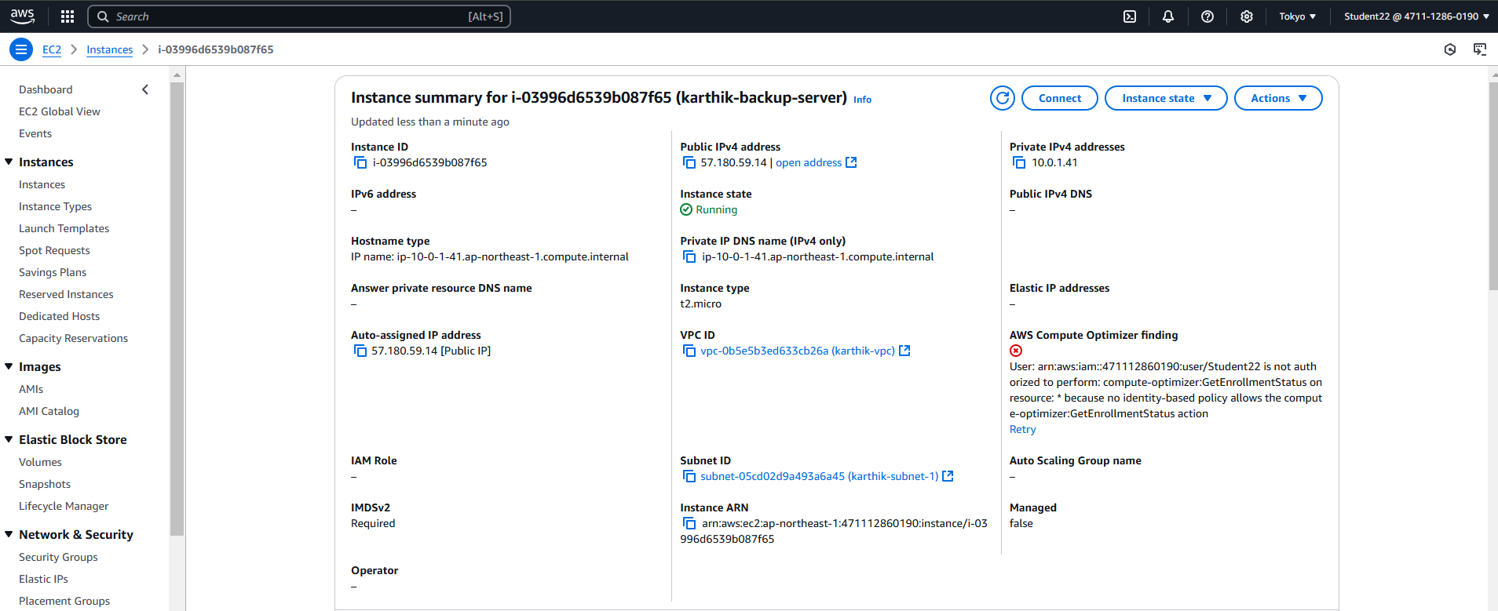

* **Created AMI’s as a karthik-backup**

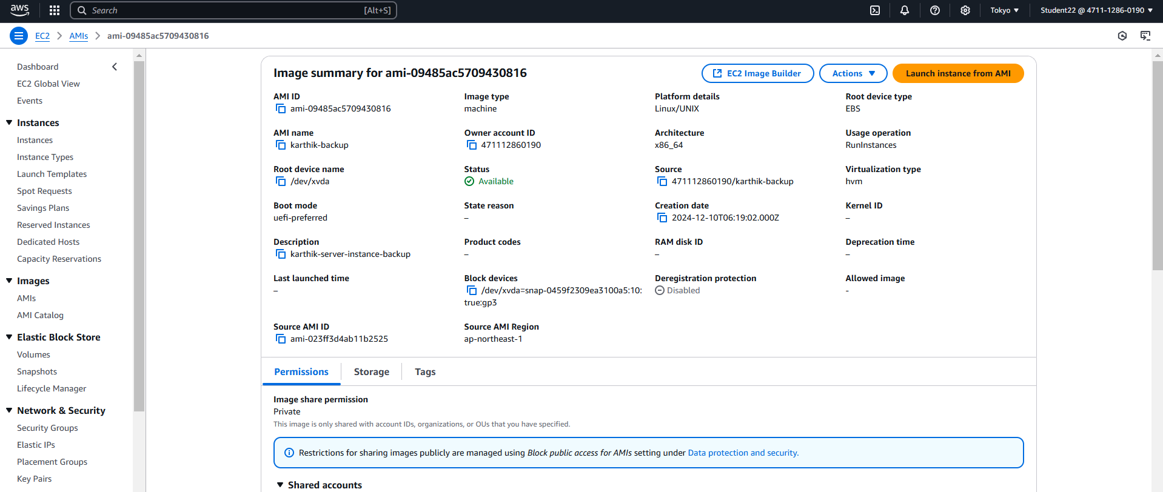

* **Final output**

